

C# Coding Standards
For Systems Integration & Test

RAYTHEON TECHNOLOGIES PROPRIETARY
This document contains data or information proprietary to Raytheon Company and is restricted to use only by persons authorized by Raytheon Company in writing to use it. Disclosure to unauthorized persons would likely cause substantial competitive harm to Raytheon Company’s business position. Neither said document nor its contents shall be furnished or disclosed to or copied or used by persons outside Raytheon Company without the express written approval of Raytheon Company. This Proprietary Notice is not applicable if delivered to the US Government.

Copyright © 2020 Raytheon Technologies
UNPUBLISHED WORK

1. Introduction 3
1.1 Purpose 3
1.2 Scope 3
1.3 Why We Need Standards 3
1.4 How to Implement These Standards 3
1.5 Document References 3
2. Coding Standards 4
2.1 Casing and Naming 4
2.2 Indentation and Spacing 7
2.3 Commenting Code 12
2.4 Error and Exception Handling 13
2.5 Strings 16
2.6 Enumerated Types 17
2.7 Variables and Constants 17
2.8 Methods 19
2.9 Classes 20

Change History
Version | Date | Description | Author
1 | 26 Jan 2015 | Document Creation | TSSC Coding Standard Team
2 | 15 September 2020 | Extensive Updates | Systems Test Coding Standards Team

Introduction

Purpose
In a company where thousands of people are employed every day to write sophisticated application code and these various people are spread out over a wide geographic landscape it becomes necessary to provide standards and guidelines for these applications.
This document was prepared to address coding standards for software engineers developing applications in C#, and more broadly, the .Net language.

Scope
This coding standards presented here are required for all C# development. Only in the case where existing code is being modified is it acceptable to make exceptions to maintain consistency with previous coding conventions.

Why We Need Standards
- Standards allow Engineers to create quality consumable code, and promotes code re-usability.
- Having a consistent look to the written code focuses reviewers on content, not layout.
- Reviewers are able understand the code more quickly by making assumptions based on previous experience.
- Standardized written code facilitates maintenance, which is the majority of software efforts.

How to Implement These Standards
The standards presented in this document are applied during software development and verified at peer review. They should be referenced in the Project’s Software Development Plan.

Document References
The following sources were referenced to produce this document:
Document | Revision | Location
Microsoft C# Coding Conventions | 7/20/2015 | https://docs.microsoft.com/en-us/dotnet/csharp/programming-guide/inside-a-program/coding-conventions
Microsoft Framework Design Guidelines | 10/22/2008 | https://docs.microsoft.com/en-us/dotnet/standard/design-guidelines/

Coding Standards

Casing and Naming
Note :
The terms Pascal Casing and Camel Casing are used throughout this document.
Pascal Casing - First character of all words are Upper Case and other characters are lower case.
Example: BackColor
Camel Casing - First character of all words, except the first word are Upper Case and other characters are lower case.
Example: backColor

Use Pascal casing for Class names

Use Pascal casing for Method and Property names

Use Camel casing all variables and method parameters
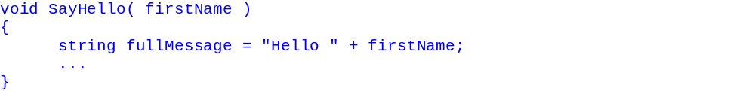

Use the prefix “I” with Pascal Casing for Interfaces ( Example: IEmployee)

Do not use Hungarian notation to name variables.
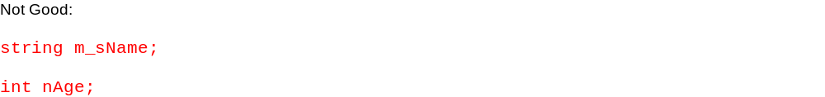

Use meaningful, descriptive words to name variables. Spell out variable names and avoid confusing abbreviations.
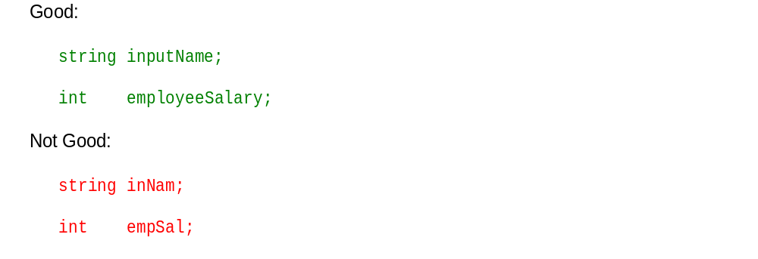
If a variable is used only as a counter for iteration and is not used anywhere else in the loop, a single character variable name may be used:

A method name should use a VerbNoun naming scheme, that way it is easier to know what the method does. Do not use misleading names. A good name will help your code be self-documenting and improve readability..
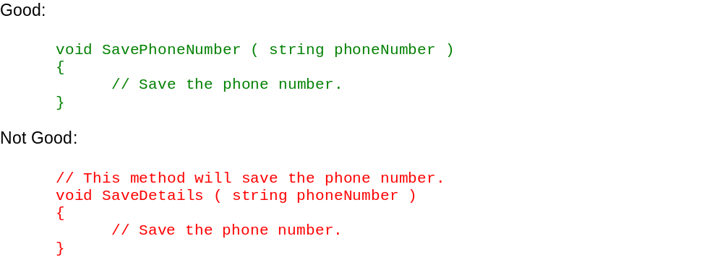

Do not use variable names that resemble keywords.

Prefix boolean variables, properties, and methods with verbs is, has, or similar prefixes – this allows for better reading in code.
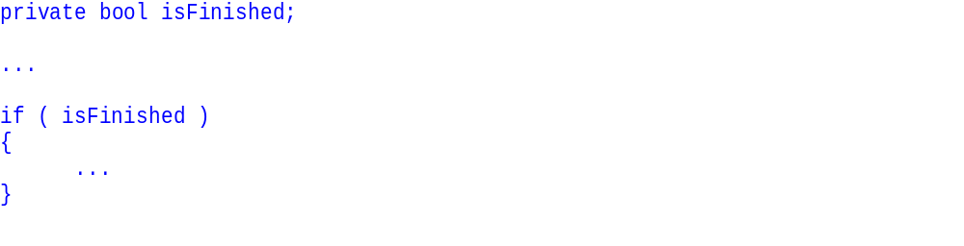

File name should match with class name.
For example, for the class HelloWorld, the file name should be HelloWorld.cs

Use Pascal Case for file names.

Indentation and Spacing

Use tab for indentation. Do not use space characters. Define the tab size as four spaces inside of the Integrated Development Environment (IDE) you are using.

Comments should be indented to the same level as the code they are commenting (use the same level of indentation).
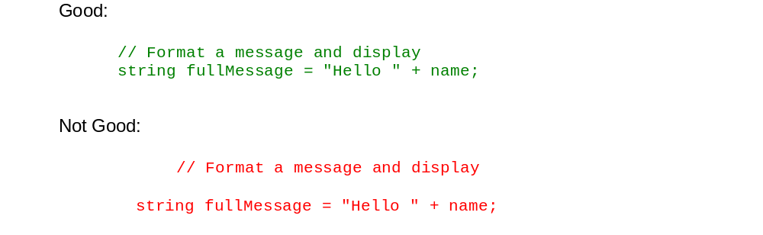

Curly braces ( {} ) should be at the same level as the code outside the braces.
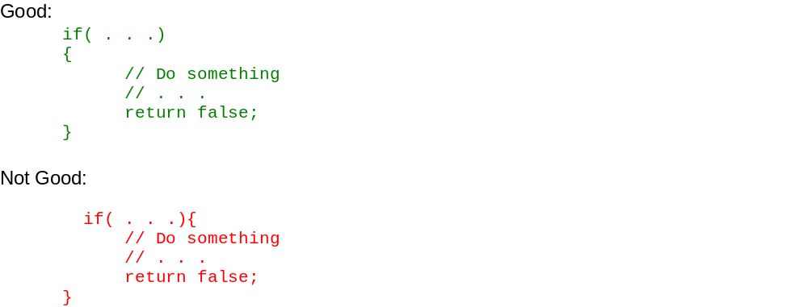

The curly braces should be on a separate line and not in the same line.
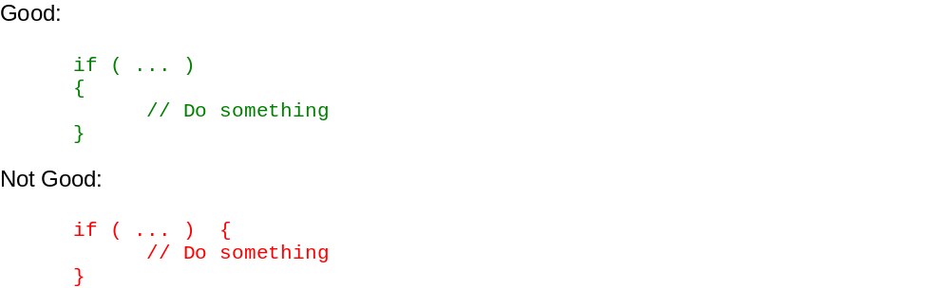

Use one blank line to separate logical groups of code.
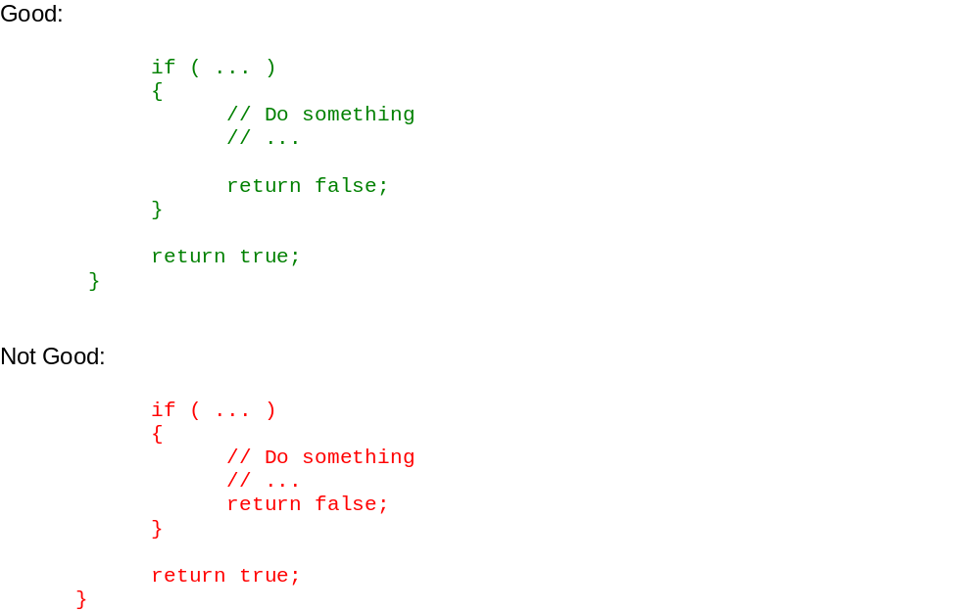
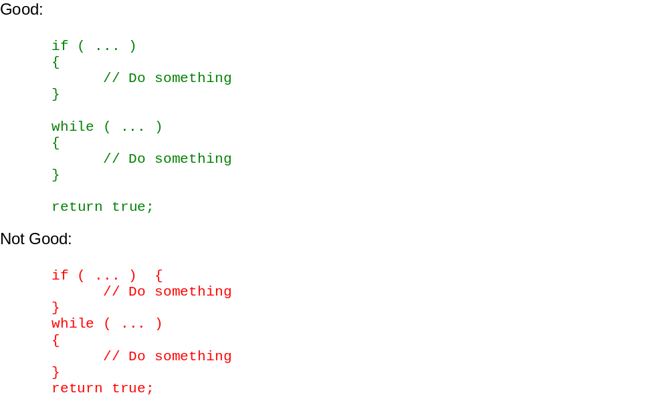

Use #region to specify a block of code that can be expanded or collapsed enabling you to focus on the part of the file you are working on.
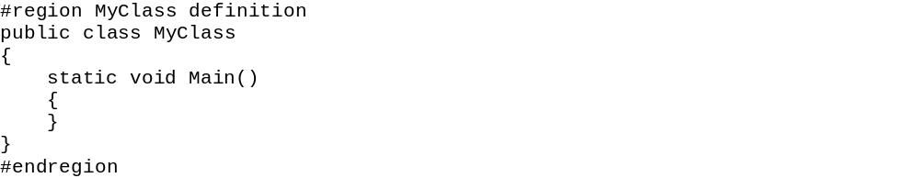
Proper use of #region should look as below when all definitions are collapsed:
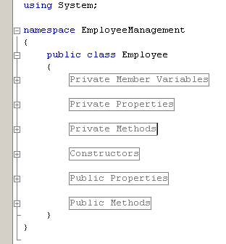
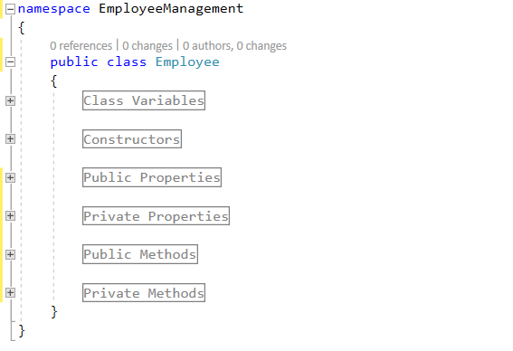

Note: Order of definitions is not important

Commenting Code

Code documentation should be sufficient for other Developers understand your code .
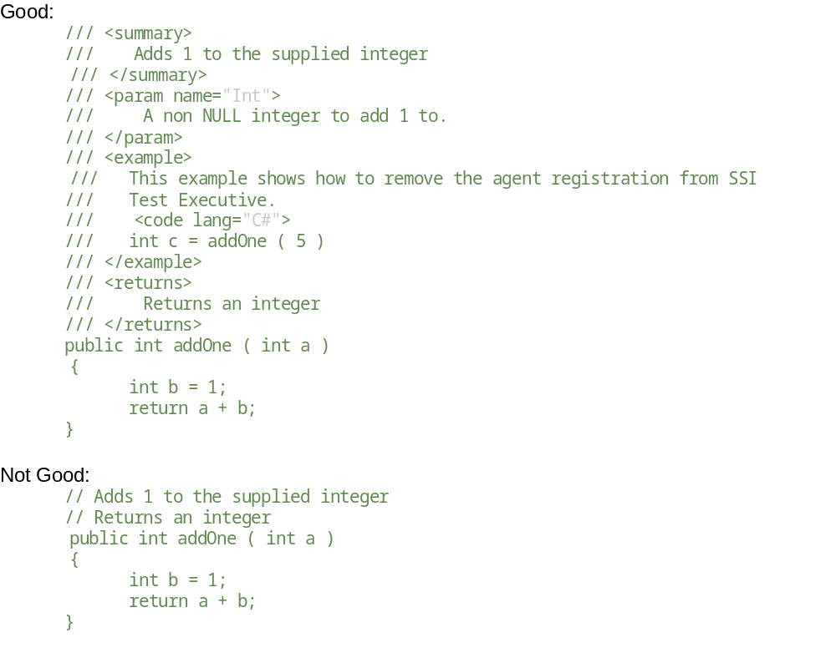

Use sandcastle XML style comments for each function that include a summary of what the function does, descriptions of input and return parameters. In Visual

Studio a triple / before the method will auto generate a comment stub in the correct format.

If you have to use some complex or obscure logic for any reason, document it well with sufficient comments.

If you initialize a numeric variable to a special number other than 0, -1, or other common initialization values, document the reason for choosing that value.

Perform spell check on comments and be sure to use proper grammar and punctuation.

Error and Exception Handling

Always validate input and provide a default case for error handling. For example, if you are using a parameter with 2 possible values, never assume that if one is not matching, then the only possibility is the other value.
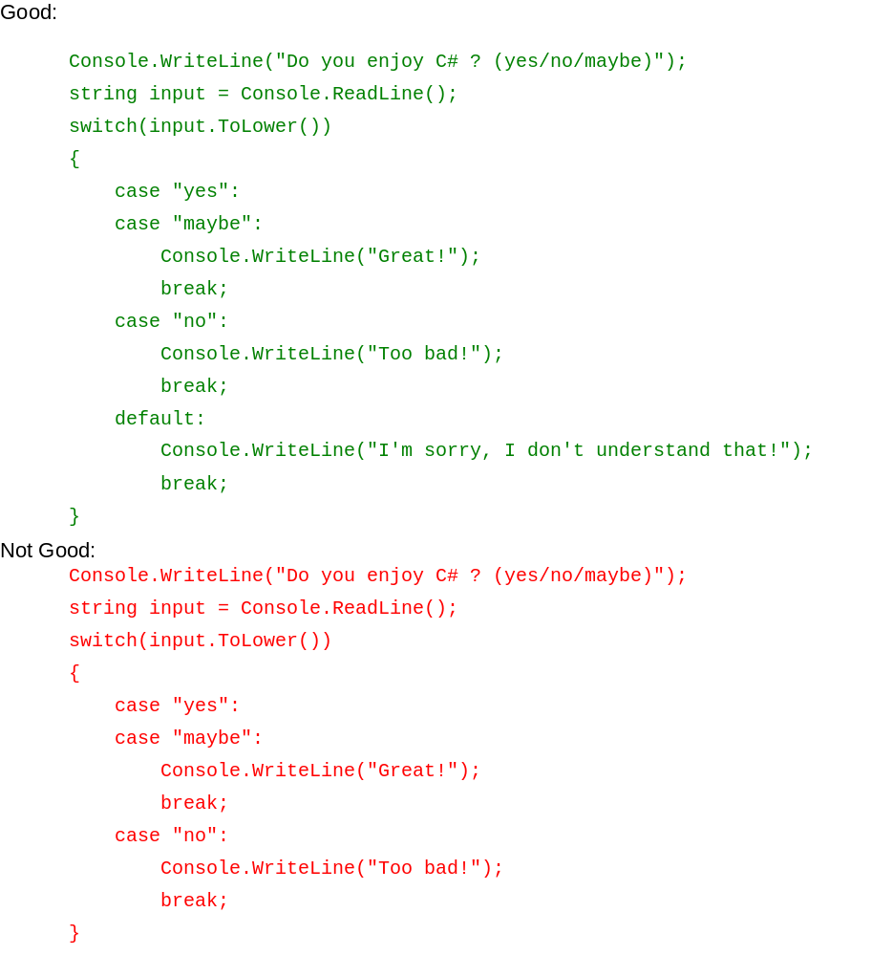

If you are opening database connections, sockets, file stream, etc., always put the code in a using block. This will ensure that if the code errors out or some other error happens, the connection, socket, etc. will safely close

Include an application level exception handler. In case of an unexpected general error, the error handler should catch the exception and log the error and the call stack in addition to giving a friendly message to the user before closing the application or allowing the user to ignore the error and proceed. If applicable, make sure power is removed. The specific syntax may vary depending on the framework being used (i.e. Windows Forms, Console, WPF, etc.). For example:

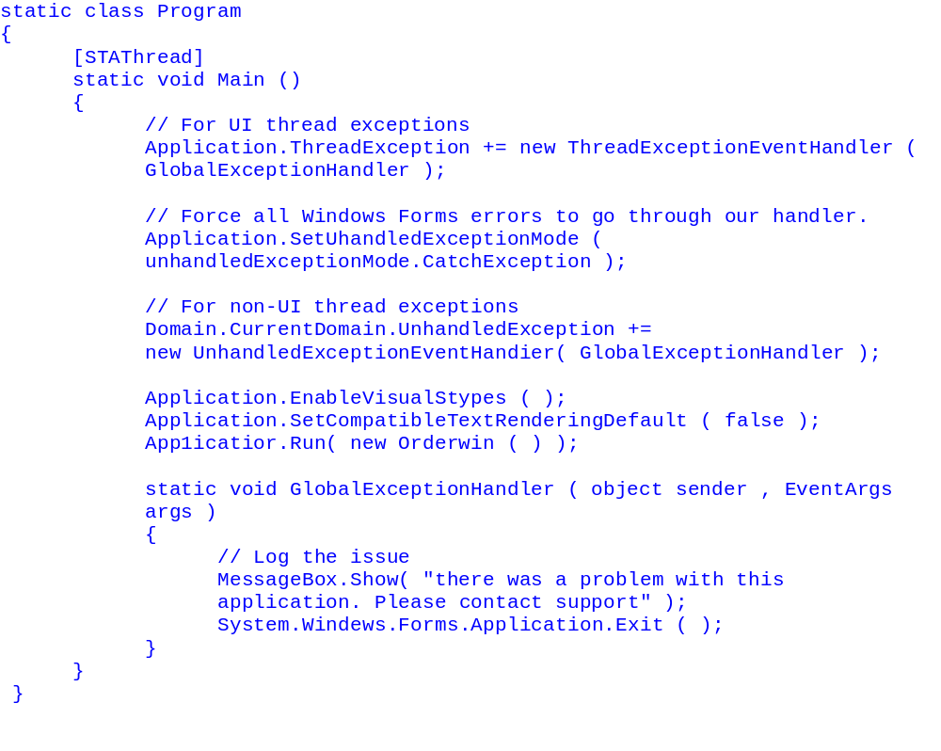

When you re-throw an exception, use the throw statement without specifying the original exception to preserve the original call stack.
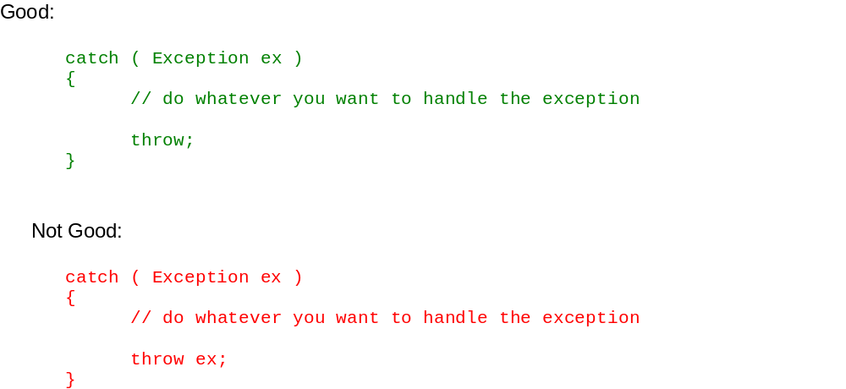

Strings

Use String.isNullOrEmpty instead of “”
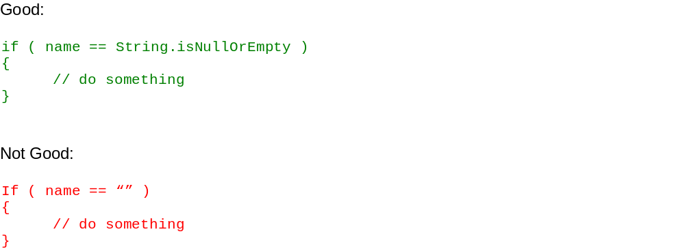

When possible, use StringBuilder class instead of String when you need to manipulate string objects in a loop.

Convert strings to lower case or upper case before comparing. This will ensure the string will match even if the string being compared has a different case.

Enumerated Types

Do not use numbers or strings to indicate discrete values, instead use enumerated types to eliminate ambiguity.
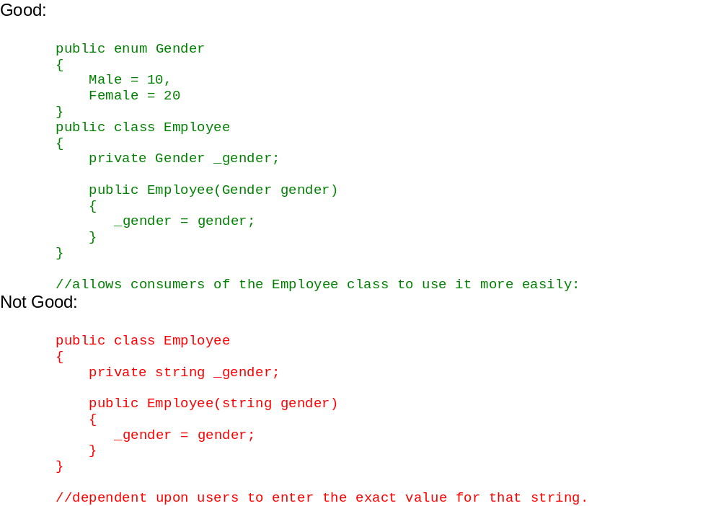

Variables and Constants

The const keyword should be used when the value never changes over the runtime period. Constants provide a named location in memory to store the value. Since the const value is already known at runtime, there is a smaller memory footprint and improved efficiency.

The use of the readonly keyword should be used when a variable should have a constant value after the constructor. These types of keywords should be used with configuration files since the value isn’t known at compilation time, however they must be known before the end of the constructor.
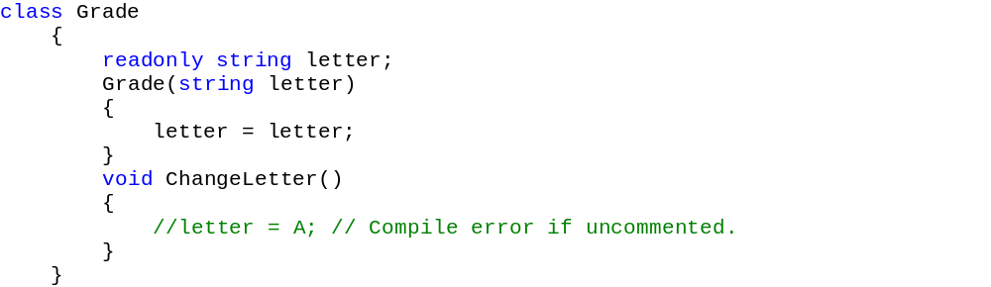

Declare local variables as close as possible to where the variable is first used. Use one variable declaration per line.

Methods

A method should do only one job. Do not combine more than one job in a single method, even if those jobs are very small.
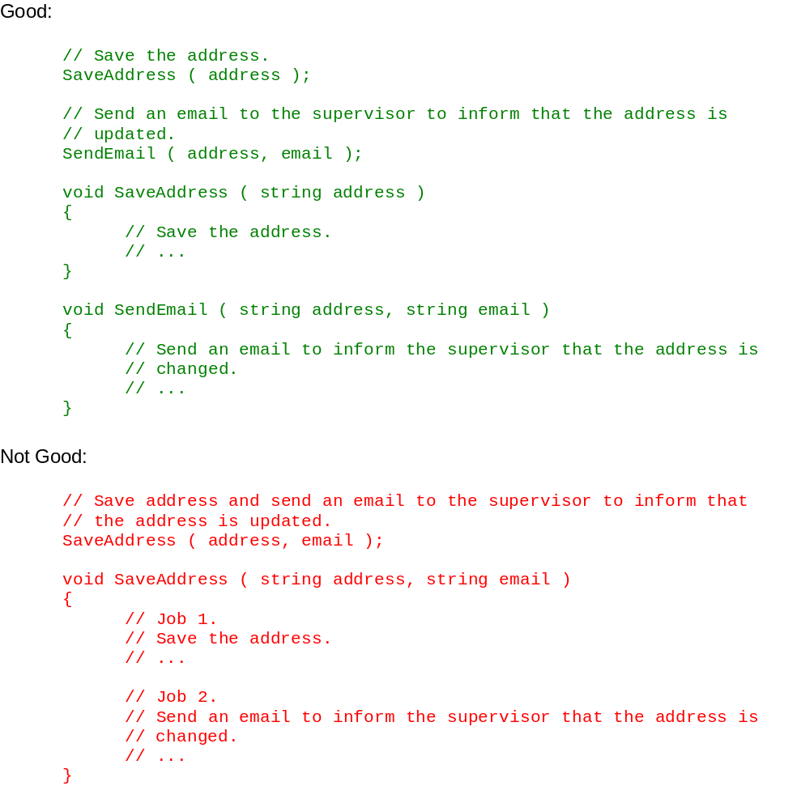

Avoid writing long methods. If a method is complex and long, consider refactoring it. Remember, a good method does one thing and does that one thing well. If your method does more than one thing then it needs to be refactored

Classes

Do not have more than one class in a single file..

